Computer Organization and Architecture
SCR 1043
Semester 2, 09/10

Tutorial: Instruction Set Architecture (ISA)
1. Discuss what is Instruction Set Architecture?

2. What are typical elements of a machine instruction?

3. What types of location can hold source and destination operands?

4. What types of operands are typical in ISA?

5. Compare one, two and three address instructions by writing programs to compute the following formula. Use all instructions covered in your class slides.
X = (A + B X C) / (D – E X F)

6. Briefly define immediate, direct, indirect, register, register indirect and displacement addressing.

7. Given the following memory values and a one address instruction with an accumulator, what values do the following instructions load into the accumulator?
- Word 20 contains 40
- Word 30 contains 50
- Word 40 contains 60
- Word 50 contains 70
- LOAD IMMEDIATE 20
- LOAD DIRECT 20
- LOAD INDIRECT 20
- LOAD IMMEDIATE 30
- LOAD DIRECT 30
- LOAD INDIRECT 30

8. Lets the address stored in the program counter be designated by the symbol X1. The instruction stored in X1 has an address part (operand reference) X2. The operand needed to execute the instruction is stored in the memory word with address X3. An index register contains the value X4. What is the relationship between these various quantities is the addressing mode of the instruction is
- direct
- indirect
- relative
- indexed

9. An address field in an instruction contains decimal value 14. Where is the corresponding operand located for:
- immediate addressing
- direct addressing
- indirect addressing
- register addressing
- register indirect adressing

10. Consider a 16 bit processor in which the following appears in main memory, starting at location 200:

200 | Load to AC | Mode
201 | 500
202 | Next Instruction

The first part of the first words indicates that this instruction loads a value into an accumulator. The mode field specifies an addressing mode and if appropriate indicates a source register; assume that when used, the source register is R1, which has the value of 400. There is also a base register that contains the value 100. The value 500 in location 201 may be part of the addressing calculation. Assume that location 399 contains the value 999, location 400 contains the value 1000 and so on. Determine the effective address and the operand to be loaded for the following address modes:
- direct
- immediate
- indirect
- register
- register indirect
- displacement
- relative

11. Given a simple instruction format as follows:
Opcode (6 bits) | Operand Reference (12 bits) | Operand Reference (12 bits)
a. What is the maximum directly addressable memory capacity (in bytes)?
b. How many opcodes are allowed for this ISA?
c. How many bits are needed for program counter (PC)?
d. How many bits are needed for instruction register (IR)?

12. What facts go into determining the allocation of bits for instruction formats?

13. Draw the instruction format the following:
- The machine operates on 16 bit words
- Total opcodes is 32
- 2 types of instructions
  - Memory Reference Instructions – Opcode 0-29, 1 bit for addressing mode, 1 bit for page, 9 bit for displacement
  - Input/Output Instructions – Opcode 30, 128 devices, 16 I/O opcode (I/O command)

- Diberikan kandungan daftar-daftar seperti berikut:

CS = 0300H | SI = 78ABH | AX = 1234H
DS = 0220H | DI = 5624H | ARRAY = 2400H
SS = 4540H | BX = 145CH | SETT = 03ACH
 | BP = 2ACBH

Lakukan perkara-perkara berikut untuk setiap soalan di bawah:

- Tentukan mod pengalamatan bagi operan pertama dan operan kedua.
- Kira alamat efektif bagi operan kedua
- Kira alamat fizikal bagi operan kedua

(i) MOV AX,BX
Op1 & Op2 = daftar,
Alamat fizikal =efektif = BX

(ii) MOV AX,[BX]
Op1 = daftar, Op2 = tak terus,
Alamat efektif = [BX] = 145CH
Alamat fizikal = [DS]*10H + AE = 02200H + 145CH = 0365CH

(iii) MOV AH,[SI]+15H
Op1 = daftar, Op2 = Indeks relatif,
Alamat efektif = [SI] + 15H = 78AB + 15 = 78C0H
Alamat fizikal = [DS]*10H + AE = = 02200H + 78C0H = 09AC0H

(iv) MOV AL,3AH
Op1 = daftar, Op2 = Segera,
Alamat efektif = Alamat arahan MOV AL,3AH
Alamat fizikal = [CS]*10H + AE = = 03000H + Alamat arahan MOV AL,3AH

(v) MOV BL,[2440H]
Op1 = daftar, Op2 = Terus,
Alamat efektif = 2440H
Alamat fizikal = [DS]*10H + AE = = 02200H +2440H = 04640H

(vi) MOV AH,ARRAY[DI]
Op1 = daftar, Op2 = Indeks Relatif,
Alamat efektif = ARRAY + [DI] = 2400 + 5624 = 7A24H
Alamat fizikal = [DS]*10H + AE = = 02200H + 7A24H = 09C24H

(vii) MOV AH,[BP]+20
Op1 = daftar, Op2 = Asas Relatif,
Alamat efektif = [BP] + 20 = 2ACB + 20 = 2AEBH
Alamat fizikal = [DS]*10H + AE = = 02200H + 2AEBH = 04CEBH

(viii) MOV DH,[BX].SETT[SI]
Op1 = daftar, Op2 = Asas Indeks Relatif,
Alamat efektif = [BX] + [SI] + SETT = 145CH + 78AB + 03AC = 90AEH
Alamat fizikal = [DS]*10H + AE = = 02200H + 90AEH = 0B2AEH

Computer Organization and Architecture
SCR 1043
Semester 2, 09/10

Tutorial: Instruction Set Architecture (ISA)

1. Discuss what is Instruction Set Architecture?

The Instruction Set Architecture (ISA) is the part of the processor that is visible to the programmer or compiler writer. The ISA serves as the boundary between software and hardware.

2. What are typical elements of a machine instruction?

Operation code, Source operand reference, result operand reference, next instruction reference.

3. What types of location can hold source and destination operands?

- main or virtual memory
- processor register
- I/O device

4. What types of operands are typical in ISA?

Addresses, numbers, characters, logical data

5. Compare one, two and three address instructions by writing programs to compute the following formula. Use all instructions covered in your class slides.
X = (A + B X C) / (D – E X F)

0 address | 1 address | 2 address | 3 address
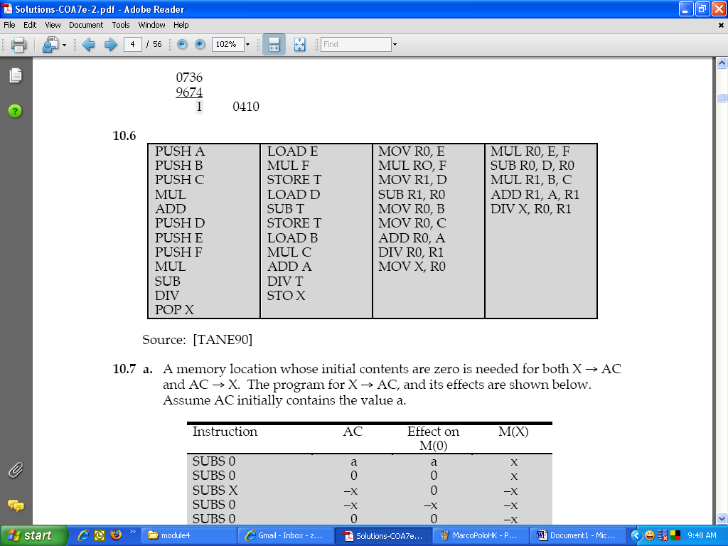

6. Briefly define immediate, direct, indirect, register, register indirect and displacement addressing.

Immediate – operand value is present in the instruction
Direct – address field contains the effective address of the operand
Indirect – address field refer to the address of a word in memory, which in turn contains full-length address of the operand
Register – address field refers to a register
Register indirect -
Displacement addressing – combines the capabilities of direct addressing and register indirect addressing

7. Given the following memory values and a one address instruction with an accumulator, what values do the following instructions load into the accumulator?
- Word 20 contains 40
- Word 30 contains 50
- Word 40 contains 60
- Word 50 contains 70

20 | 40
30 | 50
40 | 60
50 | 70

- LOAD IMMEDIATE 20 :20
- LOAD DIRECT 20 :40
- LOAD INDIRECT 20 :60
- LOAD IMMEDIATE 30 :30
- LOAD DIRECT 30 :50
- LOAD INDIRECT 30 :70

8.
- direct X3=X2
- indirect X3=[X2]
- relative X3=X2 + X1 +1
- indexed X3=X2 + X4

10. Consider a 16 bit processor in which the following appears in main memory, starting at location 200:

200 | Load to AC | Mode
201 | 500
202 | Next Instruction

The first part of the first words indicates that this instruction loads a value into an accumulator. The mode field specifies an addressing mode and if appropriate indicates a source register; assume that when used, the source register is R1, which has the value of 400. There is also a base register that contains the value 100. The value 500 in location 201 may be part of the addressing calculation. Assume that location 399 contains the value 999, location 400 contains the value 1000 and so on. Determine the effective address and the operand to be loaded for the following address modes:

A = contents of an address field in the instruction
R = contents of an address field in the instruction that refers to a register
EA = actual (effective) address of the location containing the referenced operand
(X) = contents of memory location X or register X

A = 500; R1 = 400, R_{base}=100

Memory Content:
 | OPCODE | OPERAND
ISA | Load to AC | Mode
201 | 500
202 | Next Instruction
203
399 | 999
400 | 1000
401 | 1001
500 | 1100
501 | 1101
502 | 1102
600 | 1200
601 | 1201
602 | 1202
700 | 1300
701 | 1301
702 | 1302
1000 | 1600
1001 | 1601
1002 | 1602
1100 | 1700
1101 | 1701
1102 | 1702
 | REGISTER
R1 | 400
BX | 100

Direct
EA = A = 500;
Operand = [500] = 1100

immediate
EA = 201;
Operand = A = 500;

indirect
EA = (A) = [500] = 1100;
Operand = [1100] = 1700

register
EA = R1;
Operand = R1 = 400

register indirect
EA = (R) = [R1] = 400;
Operand = [400] = 1000

displacement
EA = A + (R_{base}) = 500 + 100 = 600
Operand = [600] = 1200

relative
EA = A + (PC) = 500 + 202 = 702
Operand = [702] = 1302

11. Given a simple instruction format as follows:
Opcode (6 bits) | Operand Reference (12 bits) | Operand Reference (12 bits)
a. What is the maximum directly addressable memory capacity (in bytes)?
4096 words

b. How many opcodes are allowed for this ISA?
2⁶ = 64 opcodes

c. How many bits are needed for program counter (PC)?
12 bits in PC

d. How many bits are needed for instruction register (IR)?
30 bits in IR

12. What facts go into determining the allocation of bits for instruction formats?

Number of addressing modes
Number of operands
Register vs. memory
Number of register sets
Address range
Address granularity

13. MRI: Opcodes 5 bit, 1 bit for addressing mode, 1 bit for page, 9 bit for displacement
I/O I: Opcodes 4bit, 7bit for devices, 4bit for I/O opcode (I/O command)

- Diberikan kandungan daftar-daftar seperti berikut:

CS = 0300H | SI = 78ABH | AX = 1234H
DS = 0220H | DI = 5624H | ARRAY = 2400H
SS = 4540H | BX = 145CH | SETT = 03ACH
 | BP = 2ACBH

Lakukan perkara-perkara berikut untuk setiap soalan di bawah:

- Tentukan mod pengalamatan bagi operan pertama dan operan kedua.
- Kira alamat efektif bagi operan kedua
- Kira alamat fizikal bagi operan kedua

(i) MOV AX,BX
Op1 & Op2 = daftar,
Alamat fizikal =efektif = BX

(ii) MOV AX,[BX]
Op1 = daftar, Op2 = tak terus,
Alamat efektif = [BX] = 145CH
Alamat fizikal = [DS]*10H + AE = 02200H + 145CH = 0365CH

(iii) MOV AH,[SI]+15H
Op1 = daftar, Op2 = Indeks relatif,
Alamat efektif = [SI] + 15H = 78AB + 15 = 78C0H
Alamat fizikal = [DS]*10H + AE = = 02200H + 78C0H = 09AC0H

(iv) MOV AL,3AH
Op1 = daftar, Op2 = Segera,
Alamat efektif = Alamat arahan MOV AL,3AH
Alamat fizikal = [CS]*10H + AE = = 03000H + Alamat arahan MOV AL,3AH

(v) MOV BL,[2440H]
Op1 = daftar, Op2 = Terus,
Alamat efektif = 2440H
Alamat fizikal = [DS]*10H + AE = = 02200H +2440H = 04640H

(vi) MOV AH,ARRAY[DI]
Op1 = daftar, Op2 = Indeks Relatif,
Alamat efektif = ARRAY + [DI] = 2400 + 5624 = 7A24H
Alamat fizikal = [DS]*10H + AE = = 02200H + 7A24H = 09C24H

(vii) MOV AH,[BP]+20
Op1 = daftar, Op2 = Asas Relatif,
Alamat efektif = [BP] + 20 = 2ACB + 20 = 2AEBH
Alamat fizikal = [DS]*10H + AE = = 02200H + 2AEBH = 04CEBH

(viii) MOV DH,[BX].SETT[SI]
Op1 = daftar, Op2 = Asas Indeks Relatif,
Alamat efektif = [BX] + [SI] + SETT = 145CH + 78AB + 03AC = 90AEH
Alamat fizikal = [DS]*10H + AE = = 02200H + 90AEH = 0B2AEH

